

**Quality Assurance Plan**

ACRONYM of the project

Project Agreement No

**LOGO of the project**

**TITLE of the project**

|  |  |
| --- | --- |
| Document type (nature) | e.g. Report; Internal deliverable |
| Deliverable No | D.x.x |
| Work package number(s) | WPX |
| Document ID, Reference or Revision No |  |
| Date |  |
| Responsible Beneficiary |  |
| Author(s) |  |
| Publicity level | Confidential, Restricted, Public, etc. |
| Short description | This document is setting out the quality practices for the project, and is to provide assurance, that the quality requirements are planned appropriately. |

*Second* *page:*

|  |  |  |  |
| --- | --- | --- | --- |
| History | | | |
| Revision | Date | Modification | Author |
|  |  |  |  |
|  |  |  |  |
|  |  |  |  |

**If this was a confidential document, a similar note would be appropriate:**

*This document contains information, which is proprietary to the xxx consortium. Neither this document nor the information contained herein shall be used, duplicated or communicated by any means to any third party, in whole or in parts, except with prior written consent of the xxx Coordinator.*

*The information in this document is provided as is and no guarantee or warranty is given that the information is fit for any particular purpose. The user thereof uses the information at its sole risk and liability.*

Content

Purpose of the document

Project Management

Management Structure description

Decision-making bodies, rules, rights

Voting and quorum rules

Communication protocols

F2F Meetings

Online meetings

Mailing (lists)

Collaborative tool

Documentation and data control

Confidentiality

Identification, revision, review process

Templates, Layout

Images

Risk management

Publication and dissemination

Methods and tools

Rules and approval process

Deliverables and Milestones

Schedule

Quality standard

Process for delivery, check and archiving

Reporting

Internal Progress Reports

Periodic and Final Reporting (Official)

Annexes

Contact details

Mailing lists

Deliverable Template

Deliverable reviewers

Risk register

Internal Progress Report template

Dissemination Reporting template

***Purpose of the document***

*The purpose of a QA document is normally to define a consistent set of working procedures, quality check processes, define common standards and guidelines in order to ensure Quality standards of the Project outcomes.*

*The main objectives are to:*

* Manage the interaction between the beneficiaries during the work execution;
* Define the rules of checking the progress of the work on a regular basis;
* Detail how and when the documentation and reporting has to be done/exchanged by the beneficiaries and with the European Commission;
* Set editorial/quality standards for Project document contents;
* Develop dissemination guide if a dissemination plan is not available ;
* Give templates for support.

*Give an introduction to the project, results, and main objectives.*

*The Quality Assurance Plan is designed to be used in conjunction with the Grant Agreement, Annex I - DoA and the Consortium Agreement. It shall be used by all consortium partners. It is a living document and may be revised when needed, so it shall be reviewed at the project meetings. You may describe what happens when there is a conflict between a Consortium Partner’s internal Quality Management procedures and this Quality Assurance Plan (hereinafter QAP). It might be advisable to include a list of abbreviations, even a glossary for better clarification. Describe who holds the main responsibility for implementing the procedures, using the guidelines of the QAP – Coordinator and/or WP Leaders, etc.*

***Project Management***

*Management Structure description*

*Decision-making bodies, rules, rights*

*Voting and quorum rules*

*Describe the project management structure and main responsibilities as agreed by all partners. It is advisable to give here a list of tasks included in each work package and link one responsible partner to each task.*

***Communication protocols***

*F2F Meetings*

*Online meetings*

*Mailing (lists)*

*Collaborative tool*

*Define the number of meetings, face-to-face and online, the level of attendance by whom, the schedule, content of these meetings, their organisational rules and their evaluation process.*

*To ease the group communication, you may set up mailing lists, but define the rules for usage.*

*The online management and communication platforms are widely used in EU projects. Sometimes a simple internal section of the website accessible only for the project partners with a document and image library is enough. Sometimes you will develop/use a more complex system enabling various communication channels (wiki, chat, online video/phone discussions, etc.). Make sure the scope of the platform fits the project needs, the access rights are clear, the guideline for use are available for all partners.*

*See an example of the communication tools from the JERICO project’s QA Plan:*

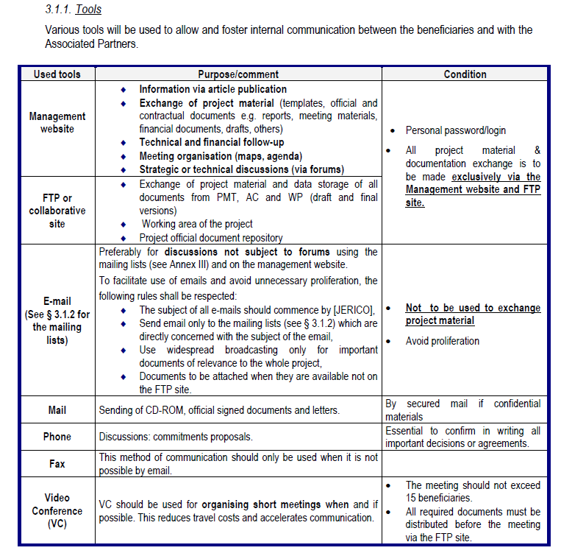

***Documentation and data control***

*Confidentiality*

*Identification, revision*

*Templates, Layout*

*Images*

*Normally partners agree that “all original data, research materials, and project records (e.g. details of events hosted) generated by participants in the Consortium/Project must be retained and available to consortium partners for a period of five years following the end of the project.”*

*Data protection might be a complicated subject. If you do not need any specific sections on that, you may say simply that: “All Consortium Partners must abide by their national legislation and EU directives in relation to the management of personal data”.*

*Regarding the data communication protocol, normally it is agreed that “all documents and computer data files sent either on CD, DVD or by Internet, e-Mail or USB disks are to be VIRUS checked before issue and to be screened on receipt”.*

*For images, you may set up a special folder to centralize all images, diagrams or photos useful for the Deliverables and other project reporting. Prior their upload on the FTP site, owners of these images, diagrams or photos should be requested to check that they are free of rights and can use by other beneficiaries under no restrictive conditions. Naming of images should be ruled.*

*Each document, deliverable normally will have an identifier that uniquely identifies each deliverable. An example:* “For a document in a draft version, the version and the revision start at 0.0. When a document is distributed internally or delivered, the Version_Revision number must always be updated. When the delivery concerns just a part of the document only the revision number is incremented. For delivery of a revision, the change control table and document change record table of the document must be updated. For a new version, if the change control table and document change record table become important, only history of Version number remains.”

*See here an example for document identification from the project ENVIRES:*

*“Each document must be referenced by a unique document identifier to ensure effective version control.*

*The nomenclature is defined as:*

*<Project name abbreviation>_<WP number>_<Document name or number of deliverable>_<Document version_number>_<Version_Revision>_<initials of the author or the last revisioner> e.g.: ENVIRES_WP1_Qualityplan_01_00_GL” This will be the name of the file as well.*

*There might be a standard documentation template developed, that will be used by all partners in order to produce standardised documentation. These templates are always based on the templates requested by the European Commission.*

*One example: “Each deliverable will contain:*

* a title page,
* a document status sheet and change record table (for evolutionary documents only),
* the file name,
* a content page,
* an (executive) summary,
* a glossary if necessary,
* a list of figures, tables,
* a list of applicable documents and reference documents (with version and date for technical documents),
* annexes as appropriate.”

*You may define that the documents should be prepared in Microsoft Word, but distributed in pdf, the language of all documents should be English, the max size of a deliverable 10MB without annexes, etc. All these details have to be tailored to your project needs.*

*If you include a list of attributes to the documents, include also a short explanation to each attribute after the table. See here an example for a table of a list of attributes from OLAREX project:*

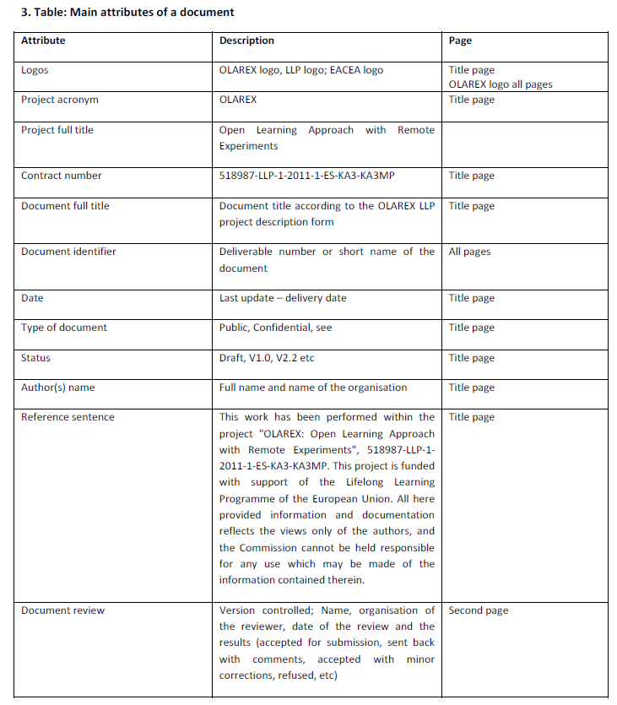

*Normally all documents, deliverables have a revision history summary table on their second page, such as e.g.:*

|  |  |  |  |
| --- | --- | --- | --- |
| History | | | |
| Revision | Date | Modification | Author |
|  |  |  |  |
|  |  |  |  |

*When a detailed review process is identified, a second summary table on the second page, will be e.g.:*

|  |  |  |
| --- | --- | --- |
| **Document Review** | | |
| **Reviewer** | **Institution** | **Date and result of Review** |
|  |  |  |
|  |  |  |

*And each document might contain if needed an approval signoff form before the table of contens, such as:*

|  |  |
| --- | --- |
| Approved by in the Consortium (signature) | Date |
|  |  |

|  |  |
| --- | --- |
| Approved by the EC | Date |
|  |  |

***Review Process***

*Schedule*

*Quality standard*

*Process for delivery, check and archiving*

*The schedule for the main project milestones, deliverables is outlined in Description of Action. Include it here as well. All deliverables will be produced and delivered in English. If other methods, languages are to be used, describe it here.*

*You have to define the quality criteria the reviewer will take into account and describe them. You have to define what these criteria mean and what their characterisation rules are. At the end of the review process, the reviewer (the WP leader, the Coordinator or an external reviewer) will fill in a short table, such e.g. this:*

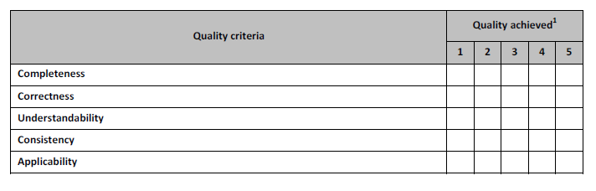

*It is up to the project needs how detailed and complex the review process is. Depth, Punctuality, Adherence to standard, writing features, etc. several other criteria might be used in the review process.*

A simple delivery process: “Before delivery to the European Commission, each deliverable will undergo a Peer Review by the Management Board in order to assess that each deliverable meets acceptable standards on the technical, quality and cost levels. This review process is documented in the change history of the document.

If it is refused, the deliverable will be modified taking into account the remarks and then a new review carried out.

The deliverables will be delivered by the Project Coordinator to the European Commission.

The final version of a document is delivered with a paper copy and an electronic copy to the European Commission. A delivery note is sent with the delivery, to describe the delivery content.”

*Another simple principle:*

*“During the development of any document or part of document, the author is responsible for the storage, change control and configuration management of the product.*

*Once a deliverable is finalised by the work package leader, the project co-ordinator should be provided with it by the author for final approval and agreement for delivery.*

*Once agreement for delivery is obtained, the coordinator is responsible for the distribution of the deliverable:*

* one copy for all partners on the project Web Site
* copies to the EC according to requirements set by the contract.

*Review must be understood as being the verification of Deliverables before submission to the Commission. The review should be performed by the coordinator in co-operation with work package leaders involved in the development of the product to be verified.*

*The reviews should be aimed to reveal any errors such as :*

* technical ambiguities or inconsistencies,
* non conformance to the philosophy and concepts developed in the description of work,
* non conformance to the requirements laid down by the Commission from time to time.”

*Describe as appropriate the review procedure, the nomination of reviewers, (you may include a template for the reviews e.g.), the consequences of the review report’s conclusion, the corrective and preventive actions.*

***Reporting and Monitoring***

*Internal Progress Reports*

*Periodic and Final Reporting (Official)*

*Project monitoring and reporting is normally performed by means of:*

* Periodic progress meetings;
* Periodic progress reporting, EC and internal ;
* Review of main project milestones;
* Reviews of all documents and deliverables by partners.

*Describe how the information will be collected, reported by the partners, what templates they will use, what information they will have to collect and who will review the reports sent by each partner.*

*e.g. WP reports developed by WP Leaders, so partners will send info to WP Leaders and the Coordinator, WP Leader will compile the WP report and it will be checked by the Coordinator. All activities related to management, dissemination, activities not related directly to a WP should be sent to the Coordinator and the Coordinator will use that and integrate it to the project report.*

***Risk management***

*Describe the risk management principles and the major risks to be monitored. Would you need a more complex section here, you may include a SWOT analysis or/and a Risk Register Table describing all identified risks, their potential occurrence schedule (if relevant) and the avoidance measures to be taken by whom.*

***Publication and dissemination***

*Authorship*

*Methods and tools*

*Rules and approval process*

*The following presentation modes are normally meant as “publication”: an article or an editorial in a refereed or non-refereed international or national journal or conference, invited/keynote presentations at a conference, a Ph.D. thesis, an internal report of an institute, an M.Sc. thesis, a conference poster not included in proceedings, a stand at a fair, a popular journal, a newspaper interview, a flyer, a newsletter, a web page, etc ...*

*Authorship issues are important. As a general rule, “authorship is reserved for persons who receive primary credit and hold primary responsibility for a published work. Authorship encompasses not only those that do the actual writing but also those who have made a substantial contribution to an article or study (e.g. research assistants). Substantial professional contributions may include, but are not limited to, formulating the research problem or hypothesis, structuring the experimental design, organizing and conducting statistical analysis, interpreting the results, having responsibility for management and funding, or writing a major portion of the paper. Those who so contribute should be listed in the byline for the piece of work.”*

*Discuss the rules agreed by all partners upon acknowledgments, author obligations, byline ordering, authorship notes and open access issues.*

*All publications should include an acknowledgment of the EU co-funding. Describe here the sentence to be used and the logos to be used by all partners.*

*It might be advisable to define the process of publications – e.g. set a 3 or 6 weeks prior notification to the partners about the publication and send them the publication draft; the date of the actual publication, the title and location and any other relevant information. Partners thus have enough time to raise protests when relevant. (The beneficiaries have the right to object to the publication in accordance with Article II.33.3 of the ECGA.)*

*When partners report their dissemination activities, you may ask the following information:*

* + Partner organisation
  + Author/presenter
  + Others involved
  + Activity type (PLEASE SELECT from the list)
  + *conference participation*
  + *Conference paper*
  + *poster*
  + *social media (LinkedIn, Facebook, etc.)*
  + *presentation*
  + *articles published in the popular press*
  + *other*
  + Title
  + Event / source name
  + Target group (PLEASE SELECT from the list)
  + *Scientific Community*
  + *Decision-makers, Policy-makers*
  + *Public*
  + *Other*
  + Size of audience
  + Date/period
  + Venue/Place
  + Link/source
  + Pictures
  + Countries addressed
  + Language
  + Status (accepted, submitted, published, pending, etc.)
  + Comments

*A template in the form of an excel sheet or a word document will be helpful.*

*Regarding exploitation activities, you may also define details on the information to be reported.*

* + Type of Exploitable Foreground
  + *General advancement of knowledge,*
  + *Commercial exploitation of R&D results,*
  + *Exploitation of R&D results via standards,*
  + *Exploitation of results through EU policies,*
  + *Exploitation of results through (social) innovation.*
  + Description of exploitable foreground
  + Confidential (Yes or No)
  + Foreseen embargo date
  + Exploitable product(s) or measure(s)
  + Sector(s) of application
  + Timetable, commercial or any other use
  + Patents or other IPR exploitation (licences)
  + Owner & Other Beneficiary(s) involved

***Annexes***

Contact details

Mailing lists

Deliverable Template

Deliverable reviewers list

Review Template (?)

Risk register – see an example

Internal Progress Report template – see an example

Dissemination Reporting template – see an example